

DAA WEEK – 2 SKILL – 2



# [A Very Big Sum](https://www.hackerrank.com/contests/daa-skill-02-array-basics/challenges/a-very-big-sum)

#include <stdio.h>

int main() {

int n;

long long sum = 0, num;

scanf("%d", &n);

while (n--) {

scanf("%lld", &num);

sum += num;

}

printf("%lld\n", sum);

return 0;

}

**A Very Big Sum Test Cases**

# [Diagonal Difference](https://www.hackerrank.com/contests/daa-skill-02-array-basics/challenges/diagonal-difference)

#include <stdio.h>

#include <stdlib.h>

int main() {

int size, diag1 = 0, diag2 = 0;

scanf("%d", &size);

int arr[size][size];

for (int i = 0; i < size; i++) {

for (int j = 0; j < size; j++) {

scanf("%d", &arr[i][j]);

if (i == j) diag1 += arr[i][j];

if (i + j == size - 1) diag2 += arr[i][j];

}

}

printf("%d\n", abs(diag1 - diag2));

return 0;

}

**Diagonal Difference Test Cases**

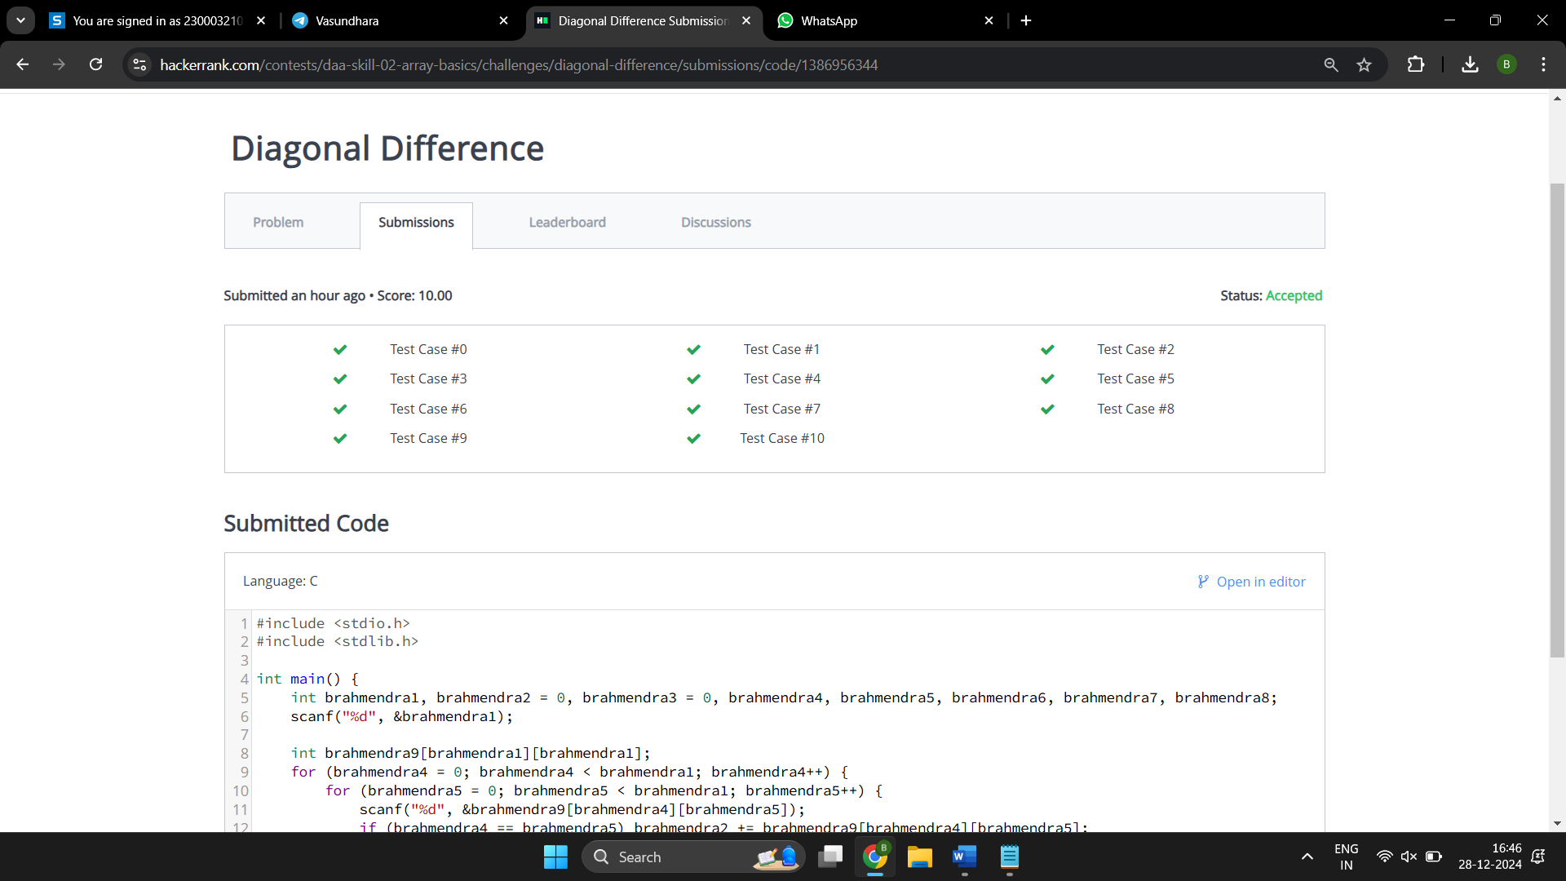

# [Number Line Jumps](https://www.hackerrank.com/contests/daa-skill-02-array-basics/challenges/kangaroo)

#include <stdio.h>

int main() {

int x1, v1, x2, v2;

scanf("%d %d %d %d", &x1, &v1, &x2, &v2);

for (int i = 0; i < 10000; i++) {

if (x1 == x2) {

printf("YES\n");

return 0;

}

x1 += v1;

x2 += v2;

}

printf("NO\n");

return 0;

}

**Number Line Jumps Test Cases**

# [Apple and Orange](https://www.hackerrank.com/contests/daa-skill-02-array-basics/challenges/apple-and-orange)

#include <stdio.h>

int main() {

int s, t, a, b, m, n, apple_count = 0, orange_count = 0;

scanf("%d %d %d %d %d %d", &s, &t, &a, &b, &m, &n);

int x;

for (int i = 0; i < m; i++) {

scanf("%d", &x);

if (a + x >= s && a + x <= t) apple_count++;

}

for (int i = 0; i < n; i++) {

scanf("%d", &x);

if (b + x >= s && b + x <= t) orange_count++;

}

printf("%d\n%d\n", apple_count, orange_count);

return 0;

}

**Apple and Orange Test Cases**

# [Between Two Sets](https://www.hackerrank.com/contests/daa-skill-02-array-basics/challenges/between-two-sets)

#include <stdio.h>

int getTotalX(int a[], int b[], int n, int m) {

int res = 0;

int i, j;

int max_a = a[0], min_b = b[0];

for (i = 1; i < n; i++) {

if (a[i] > max_a) max_a = a[i];

}

for (i = 1; i < m; i++) {

if (b[i] < min_b) min_b = b[i];

}

for (i = max_a; i <= min_b; i++) {

int valid = 1;

for (j = 0; j < n; j++) {

if (i % a[j] != 0) {

valid = 0;

break;

}

}

for (j = 0; j < m; j++) {

if (b[j] % i != 0) {

valid = 0;

break;

}

}

if (valid) res++;

}

return res;

}

int main() {

int n, m;

scanf("%d %d", &n, &m);

int a[n], b[m];

for (int i = 0; i < n; i++) {

scanf("%d", &a[i]);

}

for (int i = 0; i < m; i++) {

scanf("%d", &b[i]);

}

int total = getTotalX(a, b, n, m);

printf("%d\n", total);

return 0;

}

**Between Two Sets Test Cases**

[**www.hackerrank.com/daa-skill-02-array-basics**](https://www.hackerrank.com/daa-skill-02-array-basics)